Reporting aggregated data using group functions

1.Find the highest, lowest, sum, and average salary of all employees. Label the columns.
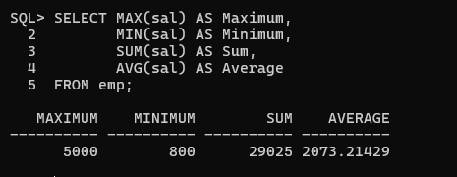

2. Maximum, Minimum, Sum, and Average, respectively. Round the average to the nearest whole number.
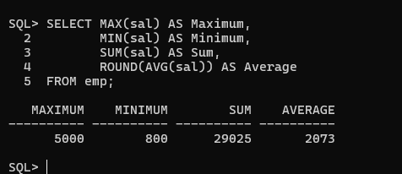

3. Display the minimum, maximum, sum, and average salary for each job type.
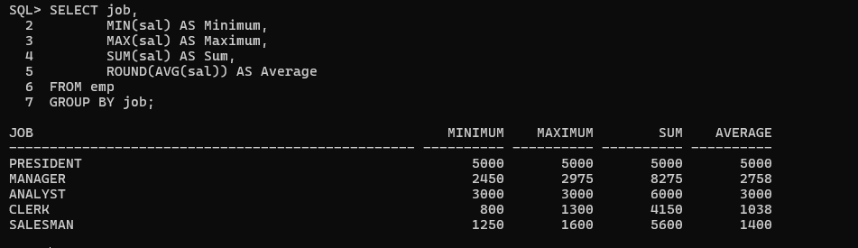

4. Display the number of people with the same job.
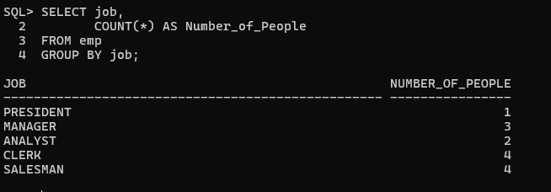

5. Determine the number of managers without listing them. Label the column Number of Managers.
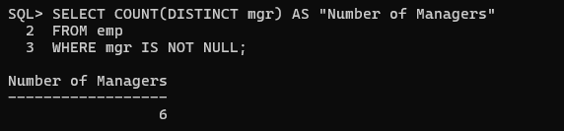

6. Find the difference between the highest and lowest salaries. Label the column DIFFERENCE.
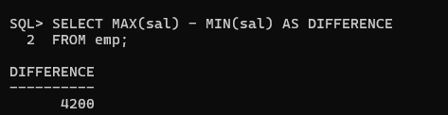

7. Display the manager number and the salary of the lowest-paid employee for that manager.
- Exclude employees whose manager is unknown.
- Exclude groups where the minimum salary is $2000 or less.
- Sort by salary in descending order.
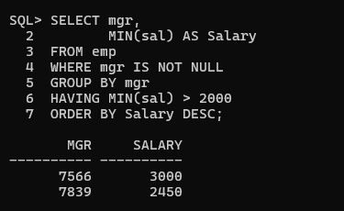

8.Display the total number of employees and, of that total, the number hired in 1980, 1981, and 1982.
